**AWS CLOOUD FORMATION**

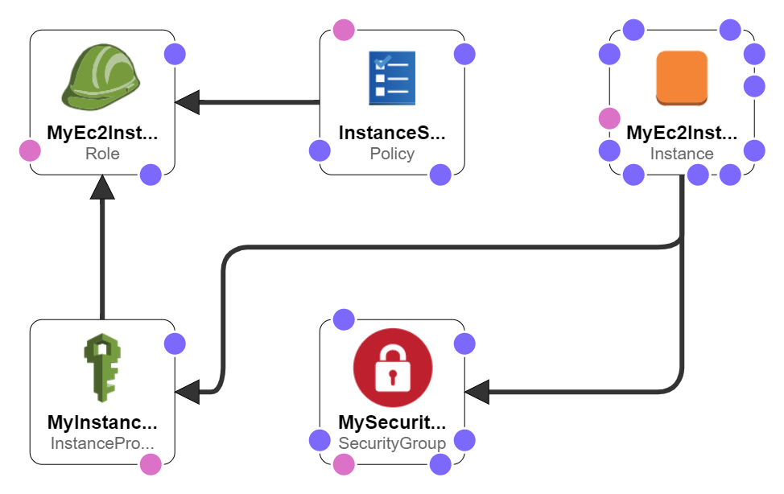AWSTemplateFormatVersion: '2010-09-09'

Description: Template for webserver with sg,intance-role and

Parameters:

  ImageId:

    Type: String

    Description: 'Linux 2 AMI for Ireland us-east-1 Region'

    Default: 'ami-033b95fb8079dc481'

  VpcId:

    Type: String

    Description: VPC id

    Default: vpc-0417ec09c53041e25

  SubnetId:

    Type: String

    Description: Subnet in which to launch an EC2

    Default: subnet-0bc683251c5bd7e52

  InstanceType:

    Type: String

    Description: Choosing  t2 micro because it is free

    Default: t2.micro

  KeyName:

    Type: String

    Description: Keypair for ssh and http

    Default: cf-webkey

Resources:

  MySecurityGroup:

    Type: 'AWS::EC2::SecurityGroup'

    Properties:

      VpcId: !Ref VpcId

      GroupDescription: SG to allow SSH access via port 22

      SecurityGroupIngress:

        - IpProtocol: tcp

          FromPort: '22'

          ToPort: '22'

          CidrIp: '0.0.0.0/0'

        - IpProtocol: tcp

          FromPort: '80'

          ToPort: '80'

          CidrIp: 0.0.0.0/0

      Tags:

        - Key: Name

          Value: EC2-SG

  MyEc2Instance:

    Type: 'AWS::EC2::Instance'

    Properties:

      ImageId: !Ref ImageId

      InstanceType: !Ref InstanceType

      KeyName: !Ref KeyName

      SecurityGroupIds:

        - !Ref MySecurityGroup

      SubnetId: !Ref SubnetId

      IamInstanceProfile: !Ref MyInstanceProfile

      UserData:

        Fn::Base64:

          !Sub |

            #!/bin/bash

            yum update -y

            yum install -y httpd

            sudo systemctl start httpd.service

            sudo systemctl enable httpd.service

            echo "Tank you sir Usama Shujaat for amazing use case" > /var/www/html/index.html

      Tags:

        - Key: Name

          Value: My-web

  MyInstanceProfile:

    Type: AWS::IAM::InstanceProfile

    Properties:

      InstanceProfileName: ec2-instance-profile-for-web

      Path: /

      Roles:

       - !Ref MyEc2InstanceRole

  MyEc2InstanceRole:

    Type: AWS::IAM::Role

    Properties:

      RoleName: ec2-instance-role

      AssumeRolePolicyDocument:

        Version: 2012-10-17

        Statement:

          -

            Effect: Allow

            Principal:

              Service:

                - ec2.amazonaws.com

            Action:

              - sts:AssumeRole

      Path: /

  InstanceS3Policy:

    Type: AWS::IAM::Policy

    Properties:

      PolicyName: DemoS3Policy

      PolicyDocument:

        Version: 2012-10-17

        Statement:

          -

            Effect: Allow

            Action:

              - s3:*

            Resource:

              - arn:aws:s3:::mysobanbucket/*

      Roles:

        -

          !Ref MyEc2InstanceRole